Assignment: Creating a Simple S3 Bucket Using Terraform
Terraform Code & Terraform Init:-
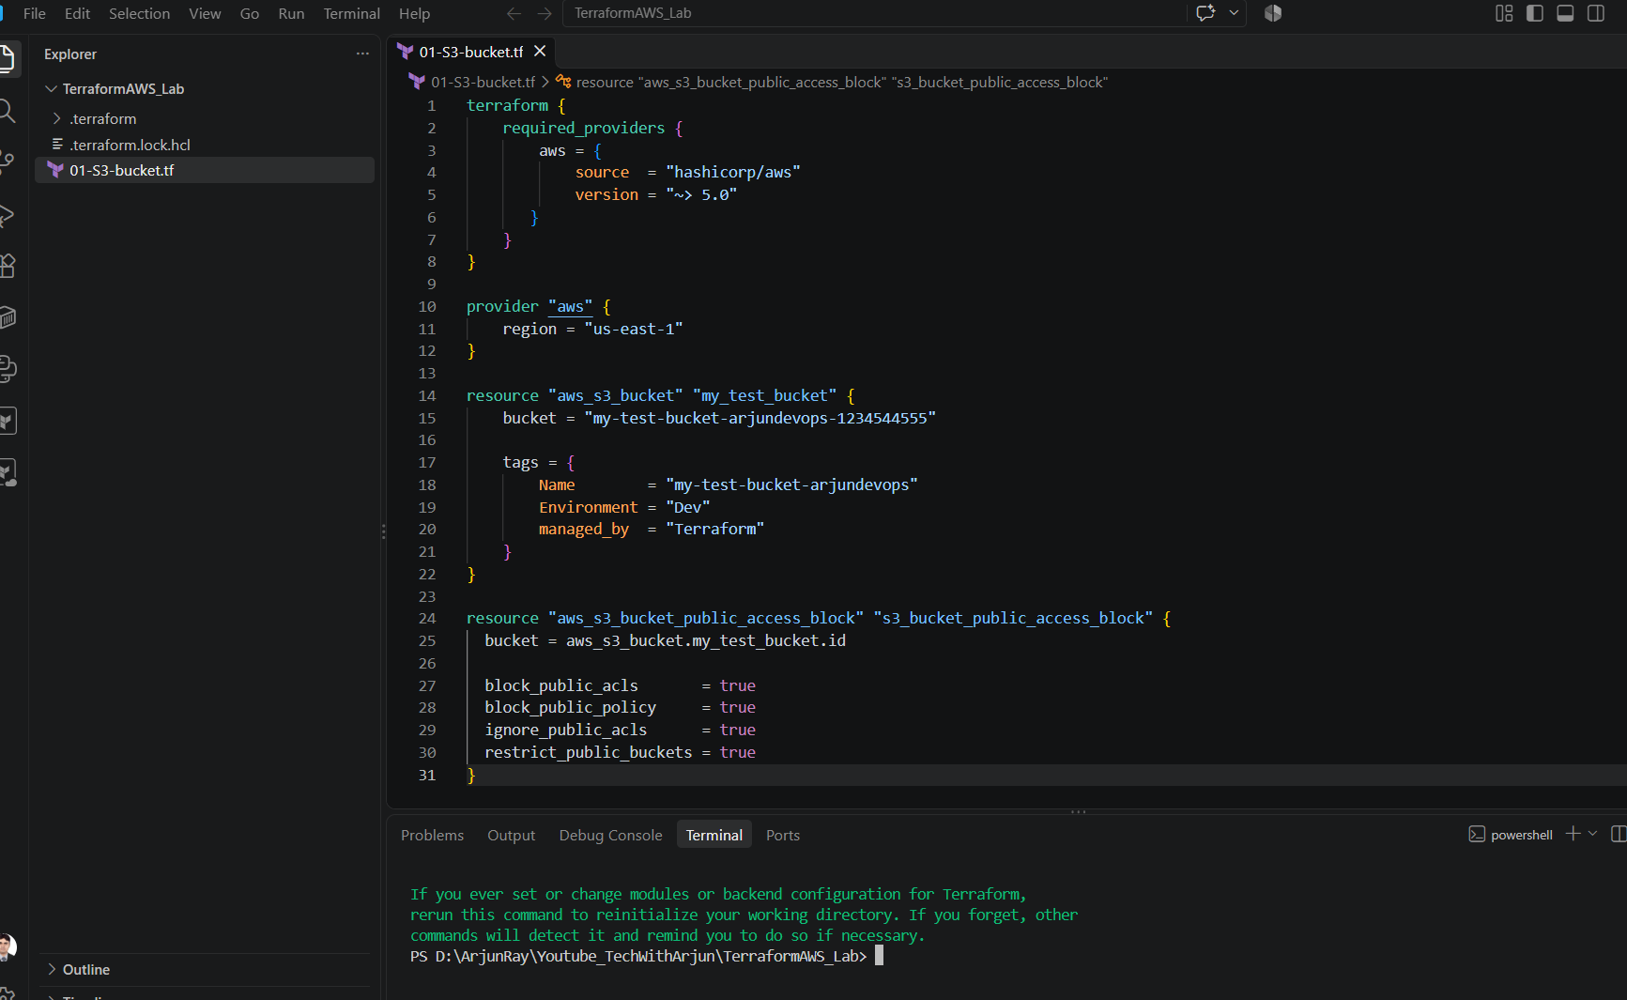
Terraform Plan
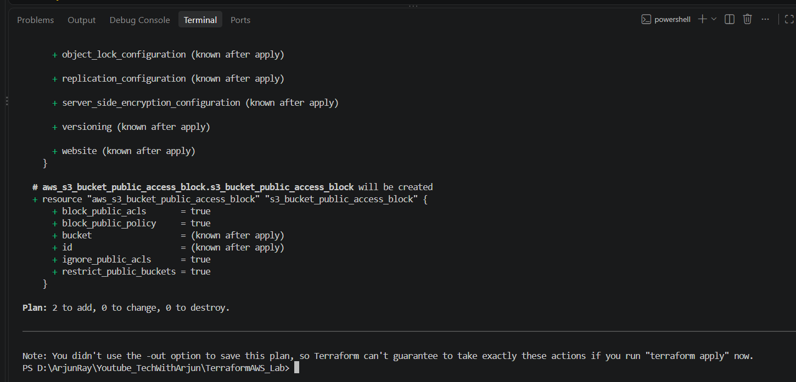
Terraform Apply
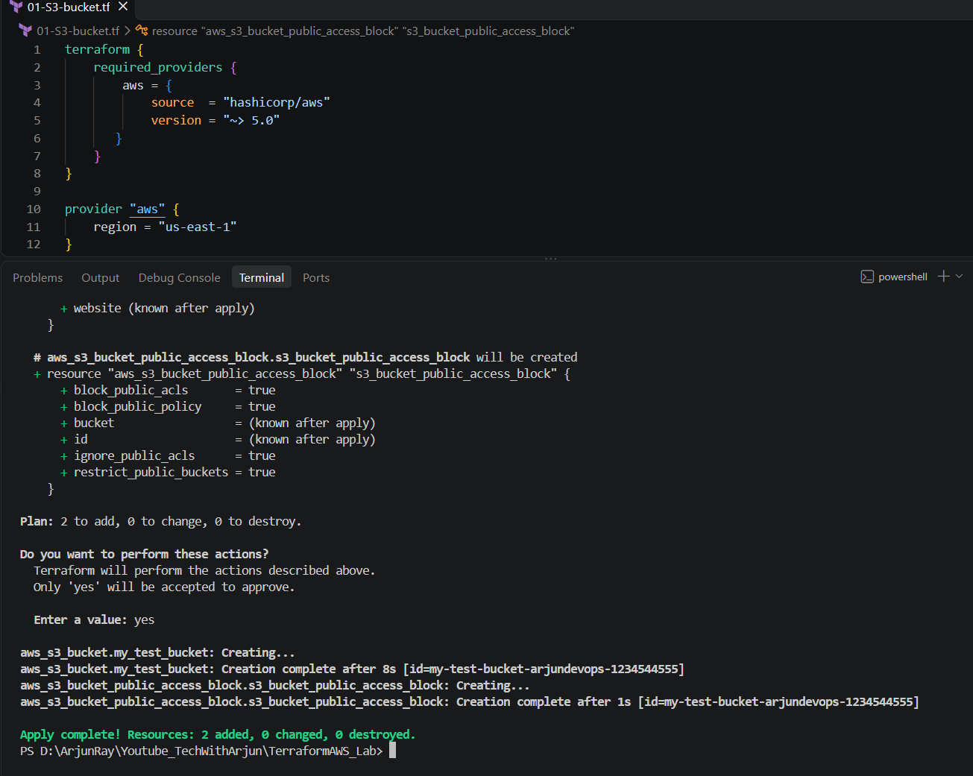
Validate resource in AWS console.
